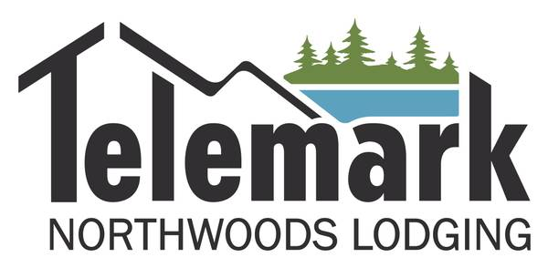

**General Manager (Cable, WI)**

**Telemark Northwoods Lodging**

**Exciting Northwoods Opportunity with Possible Housing Option!! General Manager; Hospitality Management**

**JOB SUMMARY:** We are currently seeking an experienced, enthusiastic, highly motivated individual to manage our 58-unit condominium property at Telemark Northwoods Lodging in Cable, Wisconsin. The ideal candidate will have experience in employee supervision and marketing within the hospitality industry. The manager will serve as the primary strategic business leader for the property with operational responsibilities that include guest and employee satisfaction, human resource management, financial performance and revenue generation.

REQUIRED EXPERIENCE & KNOWLEDGE:

• Experience with employee supervision and marketing.

• The ability to provide leadership showing creative and innovative ideas and strategies that maximize revenue performance.

• Excellent written and verbal communication and problem-solving skills.

• Solid organizational, time-management, and prioritization skills.

• Computer proficiency to include Microsoft Office.

• Must have or be able to obtain a Wisconsin driver’s license.

• Salary: $52-$70,000 based upon experience. Onsite housing option possible.

Please respond no later than September 30. Email cover letter and resume to: gmtelemark@cheqnet.net